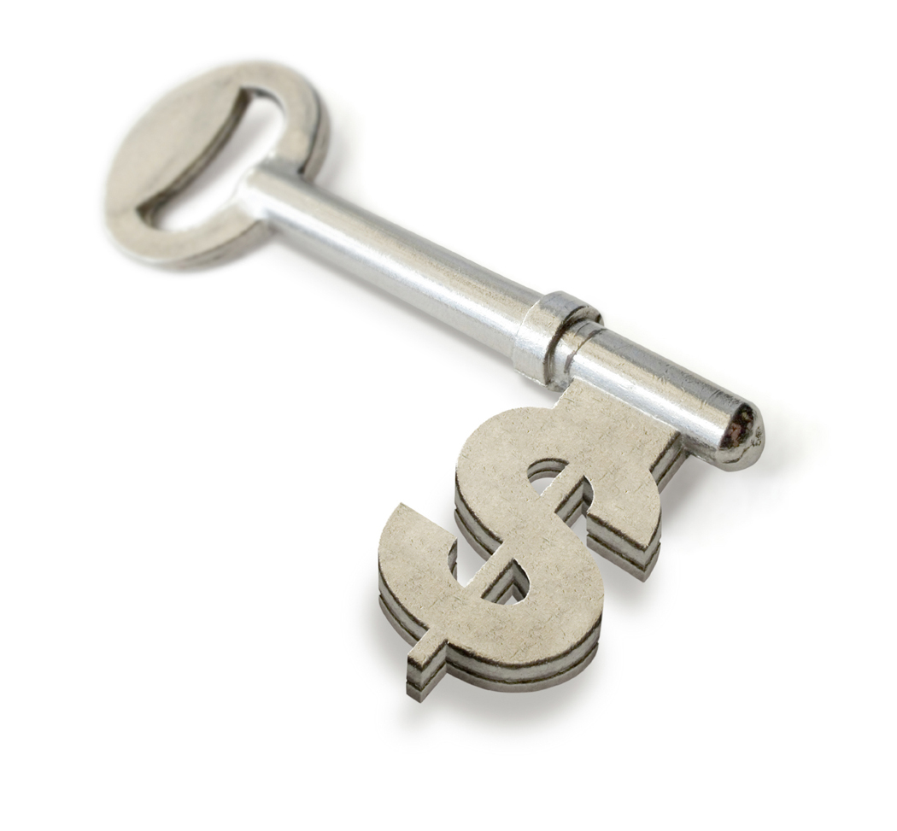

Your Key to a $1000 PARTY!

Step 1: Invite 50 People
You’ll never find a perfect night for all your guests. By over inviting and telling everyone to bring a friend, you’re sure to have plenty! You may email their addresses to me at “Your Email Address.”

Step 2: Show the Catalogs
For those guests who are unable to attend, be sure to give them the opportunity to place an order from the catalog. Try to collect them before the party. All such orders will be applied to your party! Don’t forget to mention the customer and hostess specials! Just 5 or 10 outside orders can increase your show sales by $200 to $300.

Step 3: Remind Everyone
Call each person 24 to 48 hours before the party. Let them know it’s important to you that they attend! And also, encourage them to bring a friend or two along.

Step 4: Encourage Bookings
Remember, for every party booked from your party you’ll earn an $18.00 Booking Credit. You can save your credits and apply them towards our Extra, Extra Hostess Gifts. The booking is not limited to show attendees.

Step 5: Keep it Simple
Let’s have a fun, easy and profitable party for you! Keep your refreshments simple, something salty, and something sweet! Relax! Enjoy the guests and your party!

I’ll do the best party I can for you and help you in reaching your goal! Your hostess benefits for a $1000 party will be 10 items at half price and $200 in FREE merchandise. For each booking you’ll receive an $18.00 Booking Credit or with two bookings you can select one of our Special Hostess Gifts.

