Venetian Home Collection

4 Piece Dinnerware
Service for 4
only $28.00 ($154 value—You Save $126.00!!)
(Receive this awesome Special when you use your Hostess Benefits on a $500 Party)
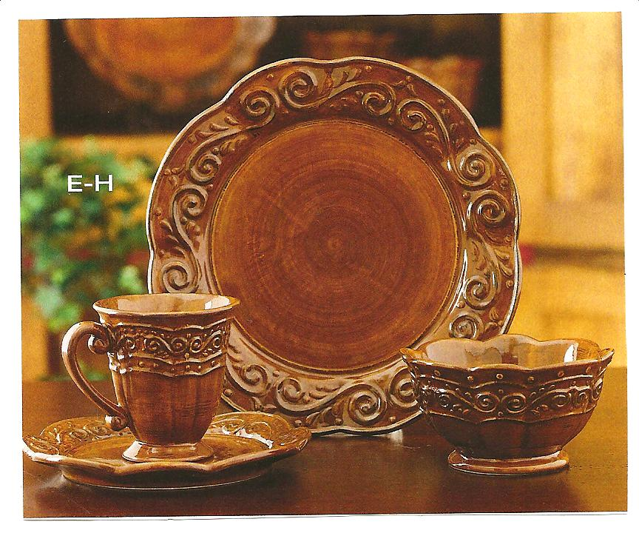
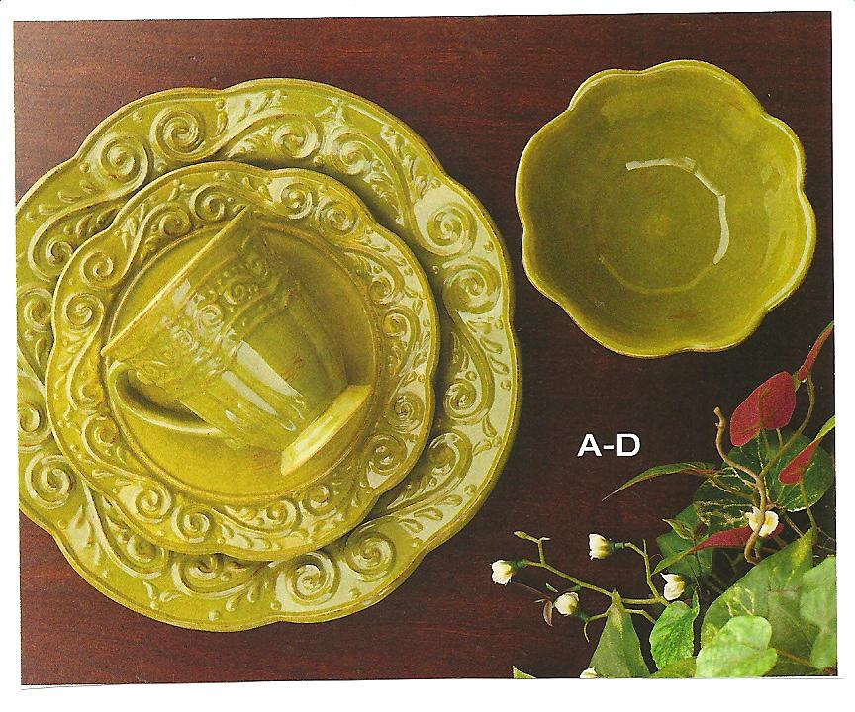
Place setting includes:
4 Salad Plates
4 Mugs
4 Medium Bowls
4 Dinner Plates

Choose any 4 additional Venetian Sets for an additional $77.00
These Sets are Half price using your Hostess Benefits!
Your Cost
- Spice or Parsley Dinner Plates $52.00 (retail) $26.00
- Spice or Parsley Salad Plates $34.00 (retail) $17.00
- Spice or Parsley Medium Bowls $34.00 (retail) $17.00
- Spice or Parsley Mugs $34.00 (retail) $17.00

Receive the Hospitality Set Absolutely FREE when you receive 2 Bookings from your Party!!
