
Spring/Summer 2008 Starter Kits

KIT A - $149 Tuscan  (Valued more than $500) | KIT B - $99 Veranda  (Valued more than $300)
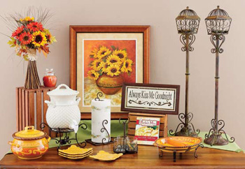 | 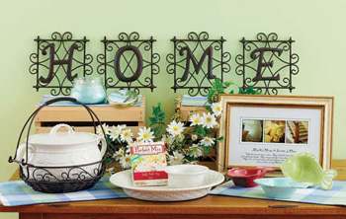
KIT C - $149 Welcome Home  (Valued more than $500) | KIT D - $99 Floral  (Valued more than $300)
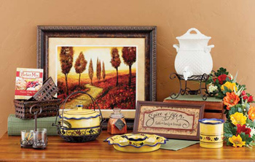 | 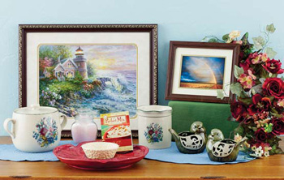
Achieve all three levels of our new Smart Start Rewards Program and receive a FULL REFUND for your starter kit. Plus, you can receive an H&GP Pin, an H&GP Nametag, up to $150 in Award Certificates for supplies and/or products and a Supply Pack with catalogs, party mailers, and order forms! In addition, earn a $50 Award Certificate for each new Designer you sponsor by the end of your first three full months. Review our Smart Start Rewards Program flyer for all the details of our exciting new program for a great 2008!

To view a larger image or our starter kits visit www.HomePartyOpportunities.com

