Want a “6 pack”?

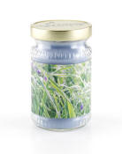 | 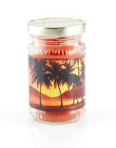 | 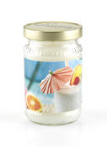 | 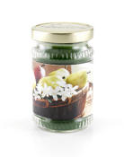 | 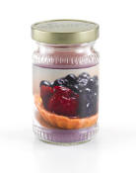

Home & Garden Party
“6 Pack” of Candles for FREE!!!
(10 oz Jar Candles in your choice of scents)

Book your own Party and Earn Up to a “6 Pack” of Jar Candles FREE!!

- Host your Party within 3 weeks and hold the Original Date = 1 FREE Candle

- Return your Guest List with 25+ names and Wish List within 6 Days = 1 FREE Candle

- Have 10 or more Guests at your Party = 1 FREE Candle

- Have 5 or more Outside Orders BEFORE your Party = 1 FREE Candle

- Have at least 1 Pre-Dated Booking before your Party = 1 FREE Candle

- Book your next Party = 1 FREE Candle

Earn a Free Candle for challenge completed!

