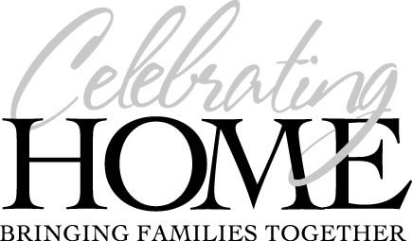

WATCH YOUR PARTY GROW

Thank you for booking your party with me. Having a party and obtaining orders just got easier! When someone is unable to attend your party OR you hosting a catalog party they can simply place their order online. Plus, friends and family from out of the area can place an order, have it shipped directly to them, and YOU earn credit towards your hostess benefits.

IMPORTANT: Watch your email. I will be emailing to you a special code (url number) your customers must use to shop online for your party. Simply forward this code to anyone not attending the party and invite them to shop. This will take them directly to a web site with your hostess name, where they can place their order and choose their shipping preference.

How this will benefit you as the Hostess:

- You can have customers from ANY location, in state or out of state.

- The orders can be shipped direct to the address of their choice for a minimal 10% shipping fee, ($5.00 minimum shipping).

- Credit for ALL sales is applied towards your hostess benefits.

- Friends will WANT to take advantage of this great new program too, which means MORE bookings for your party!

As a Hostess:
- You will receive 20% of your party sales in FREE merchandise ($200 minimum) Example: If Jane had $500 retail sales at her party, she earned $100 Bonus to spend on ANYTHING in our catalog. (party retail sales do not include bonus buys)

- Pay HALF-PRICE for any item for every $100 in sales. Example: Jane had a $500 party so she can choose 5 items from our catalog at half-price.

- Choose a FREE Hostess Gift when two or more of your guests book and hold their own qualifying party OR $18.00 FREE product of your choice for each party booked and held.

