

1st Home Party Business to reach 100 million in Sales in first 5 years

Debt Free Christian Based Company.

Industry’s Leading Home Décor Party Plan Company.

Top Hostess Plan

Leading Industry Compensation Plan

Earn 30%-45% from the start.

Earn More $$$ while teaching others. Up to 9%

A large Variety of Products affordably priced.

The rewards are endless. Prizes, Cash bonuses, Jewelry, and Trips.

Fun and Interactive Parties and demonstrations

Top Fundraising Program, Earn 50%

Online Ordering

Online E-Parties

Incredible Training online & interactive

Full Time, Part Time, or Temporary
Designer Positions.

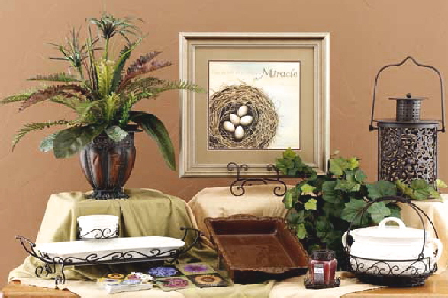
Kit A
Veranda Pottery

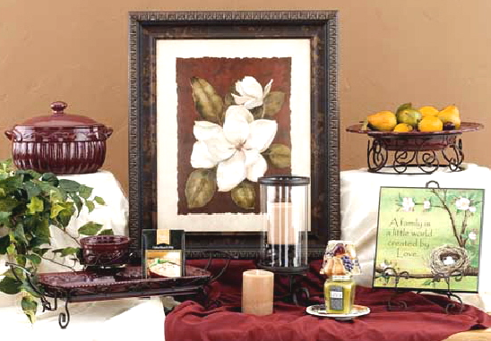
Kit B
Berry Pottery

With
Celebrating Home….Bringing Families Together

Celebrating Home has combined the Best of the Party Plan Industry together as one.
Home and Garden Party with the Purchase of Home Interiors has now changed its’ name
to
Celebrating Home…Bringing Families Together.
Join us in Celebrating Women, Celebrating Families and in turn bringing families together!
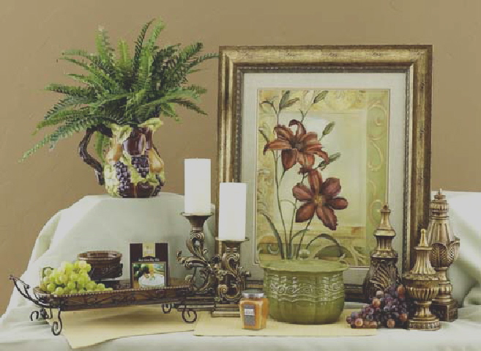
Kit C Venetian Home

Kit Includes shipping, products, and supplies valued at over $500, Start now for $175.
Earn your kit back for free plus over $150 worth of gift certificates for Supplies and/or products.
Training at every step! Awards and Recognition. Plus be paid what you are worth!

Earn 30%-49% on Retail Sales

