Hostess
Challenge
Hostess Candle or Perfect Mix Challenge
Earn a “4 Pack” of our 10 oz. Candles or
4 “Perfect Mix” Food Items Free!!!

1
Return your Guest list and Wish list within 5 days
1 FREE Candle or “Perfect Mix” Food Item
2
Collect $150 in outside orders PRIOR to your Party
1 FREE Candle or “Perfect Mix” Food Item
3
Have 15 adult buying Guests at your Party
1 FREE Candle or “Perfect Mix “Food Item

Have 2 Bookings before your Party
4
1 FREE Candle or “Perfect Mix” food item

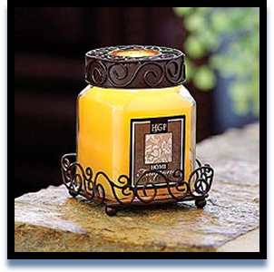 | Your Celebrating Home Designer:
