Your Unique
Bridal Shower

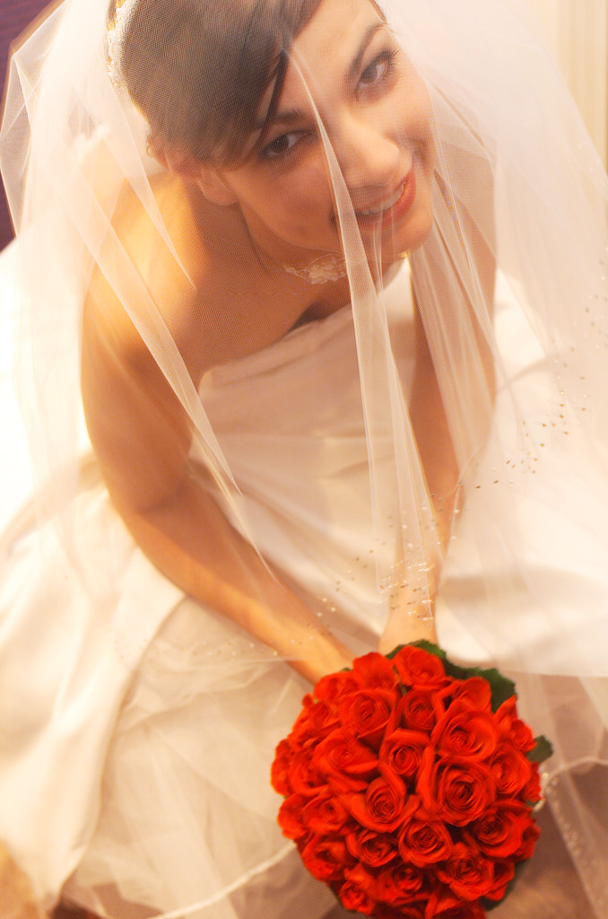

Decorate your new home
with beautiful items from
Celebrating Home

