Having a
Celebrating Home
Bridal Shower

Who hosts the Bridal Shower?
Traditionally, the event is hosted by the Maid/Matron of Honor (with other bridal attendants assisting, if agreed on). Nowadays it is not uncommon for more than one friend to throw a shower, and in many places it is no longer considered inappropriate for a family member to be the host.

When should the Bridal Shower occur?
It normally occurs from several months to two weeks before the wedding. Do not hold it too close to the wedding because it becomes such a busy time. Having the shower a few months prior gives the bridal party a chance to get to know each other and gives the bride tome to finish the thank you notes before the wedding.

Where should the Bridal Shower be held?
Affordability is the key in this decision. It could be held in someone’s home, on a patio or backyard, or reserve a room at a clubhouse or church.

Who pays for the Bridal Shower?
The host or hosts are responsible for the costs associated with the shower. If the hosting is shared, who pays for what should be determined at the onset. Decorations and food need not be elaborate; showers are most often thought of as casual get-togethers. The largest cost usually incurred is that of prizes for the shower games. With Celebrating Home, all t he games and prizes are supplied for you.

What about the Guest List?
Those typically invited include female members of the bride and groom’s family, all bridesmaids, and close friends of the bride. Only invite those who are also invited to the wedding. The Bride needs to create this list. If more than one shower is being held, be sure that people aren’t invited more than once causing a financial burden on them. Get the guest list as early in the planning stages as possible. You need to know the amount of people that will be attending to decide on location, food, etc.

How does the Gift Registry, Invitations, and Purchasing of Gifts work with Celebrating Home Bridal Showers?
The Gift Registry needs to be completed by the Bride & Groom and supplied to the hostess with the Guest List. This registry will be included in the invitations that we will mail. This saves you the expense of invitations and postage. Invitations will have an RSVP to the hostess. If they have not responded by the response date, the hostess should call the guests and ask if they will be attending. If they are unable to attend, they may place an order with the hostess at that time. All gusts attending make their gift selection from the registry and place their order at the shower. The gifts will then be delivered directly to the one hosting the party in two to three weeks.

What takes place at a Celebrating Home Bridal Shower?
The primary activities are having a good time, laughing, and eating. Throughout the shower, the guests will be able to earn “auction dollars” by answering questions about the bride and groom. Then there will be an “auction” game where the guests will be able to bid on some fun gifts. Celebrating Home items will be shown to the guests, many of which will be ones selected by the Bride & Groom on the Gift Registry. The guests will be able to order gifts for the Bride and for themselves as well. In addition to the gifts ordered for the Bride, she will receive all the free merchandise hostess benefits and any items at half price that have been earned.

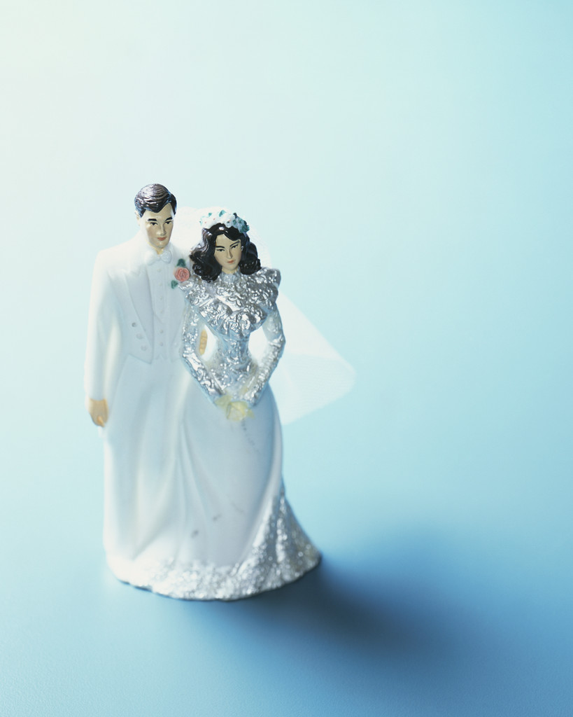
It works best if beverages are served at the beginning and then the food served at the conclusion when guests are ordering. Typically, the food is simple finger-foods: Chips, pretzels, veggie tray, cake…just typical snack or dessert foods. Beverages might be coffee, tea, punch, or soft drinks. The shower will last approximately two hours – it all depends on how long you want and how long guests stay to visit with the Bride. The most important thing is for everyone to have a good time and for the Bride to receive wonderful things for her new home!

For more information,
please contact me at
the phone number on the back.

