5 Easy Steps
To a
Unique Bridal Shower

- Working with the Bride and the Celebrating Home Designer, choose the date and time for the shower. Then decide on the location.

- Working with the Bride, complete the guest list by writing down the names, addresses, and phone numbers of the guests to be invited.

- Ask the Bride and Groom to complete the Gift Registry of items they want for their new home.

- Mail the registry, guest list, and the location information to me at the address on the back of this brochure.

- Plan the refreshments, decorations, party favors if desired, and the rest is taken care of for you!

THANK YOU
for your interest in having a Celebrating Home Bridal Shower!

Please contact me for more information:

Information is also available on our other services: In-Home Parties, Book Parties, Candle Parties, Fundraisers, and Income Opportunities!

Your Unique
Bridal Shower
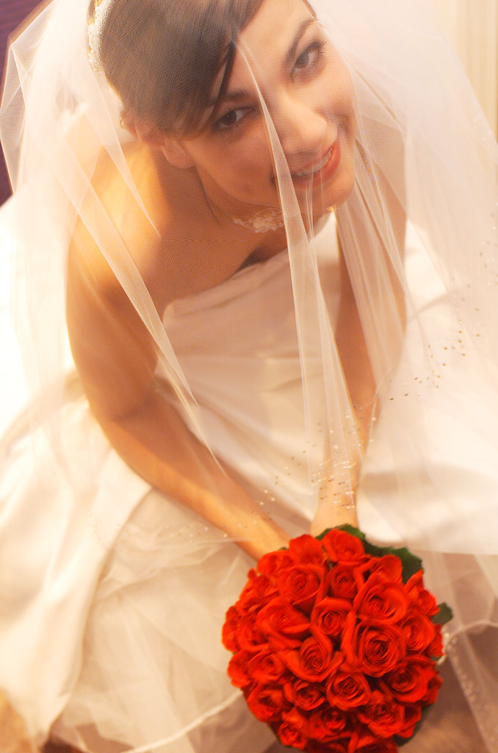

Decorate your new
home with
Beautiful items from
Celebrating Home

